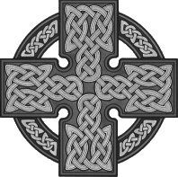
Directions: Read the Historical Context section in your textbook on pgs. 23-27, following the headings below. Use the questions below to guide your reading.

Centuries of Invasion
1. Explain WHY the Anglo-Saxon period is also called The Dark Ages.

2. What did the Romans contribute to British society?

3. Who were the Angles and the Saxons?

4. How did England get its name?

5. What did Alfred the Great accomplish?

6. Why did William the Conqueror invade England?

7. The Battle of ___________ in ________ is also called the ____________ Conquest.

Cultural Influences
Use the MAP on pg. 25 to answer the questions below. You do NOT need to read this section.

8. Based on the map, what amount of England was Christian by 500AD?

9. The spread of Christianity seemed to be centered around what body of water?

Literature of the Times
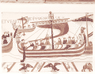10. Describe the tales told by the Anglo-Saxon scops:

11. What is an Epic?

12. How were these poems shared and enjoyed?

13. What were lyric poems about?

14. What was the typical subject matter of these poems?

Old English – using the side bar
15.What are some words from Old English that we still use today?

