Remind
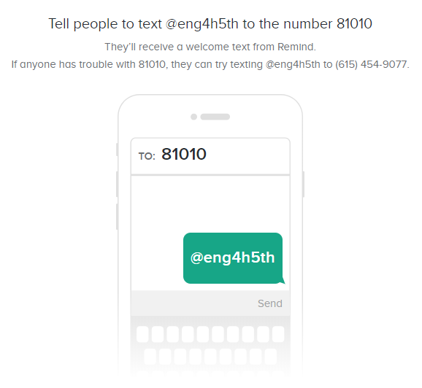
Text to: 81010
1st period: @engde1
2nd period: @engde2
4th period: @engde4
7th period: @engde7
8th period: @engde8

5th period: @eng4h5th

