Once you have a school login (i.e., you can sign in to school computers), go to the Smyrna website < http://www.shs.rcschools.net/>
From there, select Students Student Resources
Click on the Clever button.
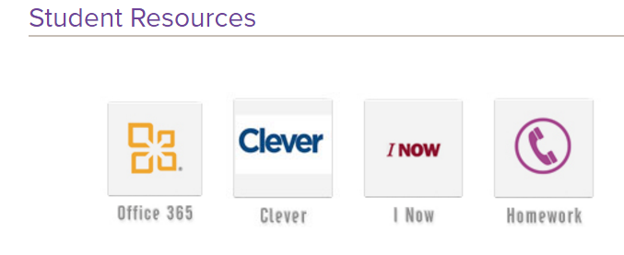
Select Log in with Active Directory.
If it prompts you for a log in and password, use your Smyrna log in and password (it’s the same that you’ll use to sign on to school computers).
Click the Vocabulary button.
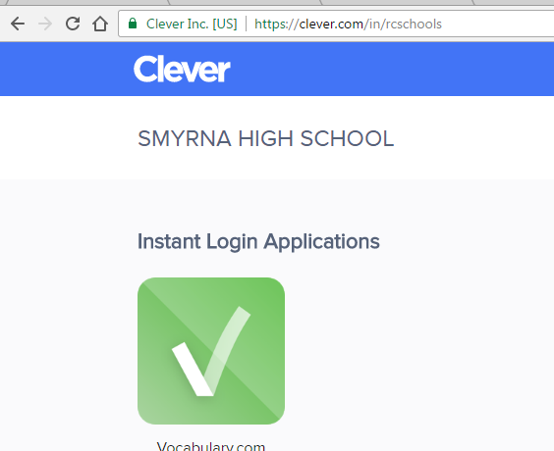
You may need to set up an account.
Remember that you must log in this way every time (SHS -> Clever -> Vocab), or it won’t log your progress.
Once you have an account set up and are logged in, then I can give you our class code to join the course.

